*You are the voice of the food transportation companies. You know that without you, food cannot go from farm to consumer in a timely manner.*

**Background Information:**

*.*

* Developing countries have poor transport systems and worldwide, 50% of all food produced never reaches consumers
* Inadequate infrastructure and storage facilities lead to a great deal of wasted food.
* There is the potential to provide 60-100% more food by eliminating loss and waste through investment by countries to improve roads, transport systems, and storage systems for food worldwide.
* This is not just a developing nation problem! Engineers worldwide have a crucial role to play in developing new, energy conserving technologies to process, transport, store and distribute food goods throughout the world.
* Governments, development agencies, world organizations need to include transport companies and engineers to develop and implement new strategies and technology to get food to people.
* The roads and materials used to transport food need to be safe, economical, fast, and reliable.
* Food transport system companies need to work closely with the agricultural supply companies to provide a safe “pipeline” for food products from fields to shelves.

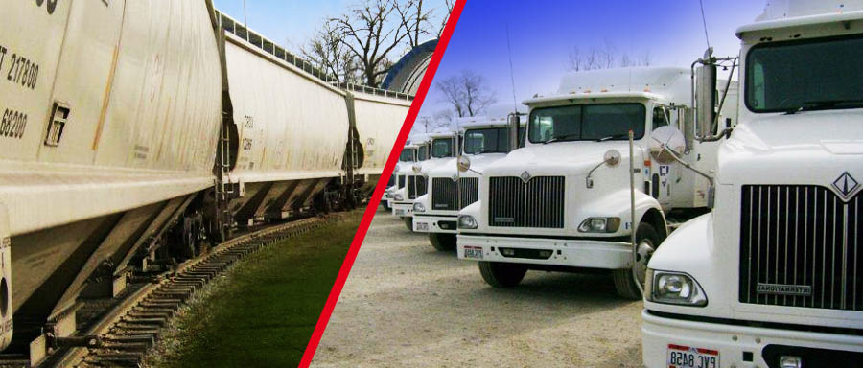

<http://rgoodenterprises.com/images/truck_train2.jpg>